Assignment 3
Name : Prathmesh Marathe
PRN : 123B1B186
Div : C

Assignment Title : Design a Dynamic Web Application for an E-Commerce / Fashion Store using HTML, CSS, and JavaScript (using Bootstrap CDN).

Objectives :
- To understand the structure of a dynamic web application
- To design an e-commerce / fashion store interface
- To use HTML for page structure and content layout
- To apply CSS for styling and responsive design
- To implement JavaScript for dynamic functionality
- To use Bootstrap CDN for faster UI development

Outcomes :
- Design a dynamic e-commerce web application
- Implement client-side logic using JavaScript
- Use browser storage (localStorage) for cart and user data
- Create reusable UI components such as navbar and footer
- Filter products dynamically based on categories
- Build a functional shopping cart system

Theory :
A dynamic web application is a website that responds to user interactions in real time without reloading the entire page. Unlike static websites, dynamic applications use JavaScript to manipulate the Document Object Model (DOM), fetch data, and update content dynamically.
In an e-commerce web application, common features include:
- Product listing and filtering
- User registration and login
- Shopping cart management
- Dynamic price calculation
- Responsive UI
HTML is used to structure the content, CSS is used for styling and layout, while JavaScript adds interactivity such as product rendering, cart management, and form validation.
Bootstrap CDN is used to ensure responsiveness and consistent design across devices.

Dataset Used :
- Dataset Name: E-Commerce Products Image Dataset
- Source: Kaggle ( https://www.kaggle.com/datasets/sunnykusawa/ecommerce-products-image-dataset )
- About the Dataset
Contains real-world product images of:
- Sofas
- Jeans
- T-Shirts

Program Code :
https://github.com/Prathmesh-Marathe/FSDL_LAB/tree/main/Assignment_3

Output :
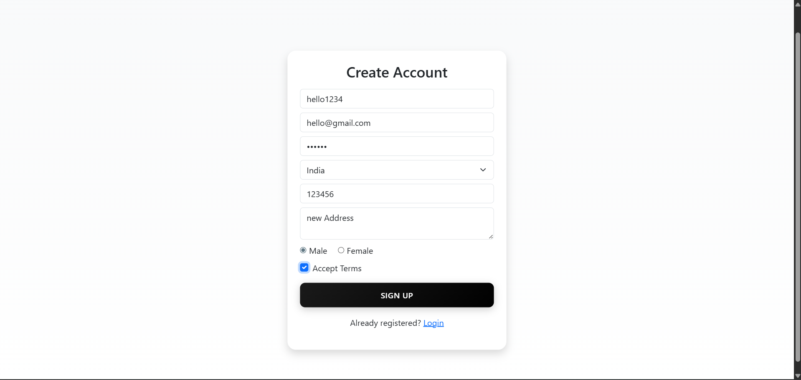
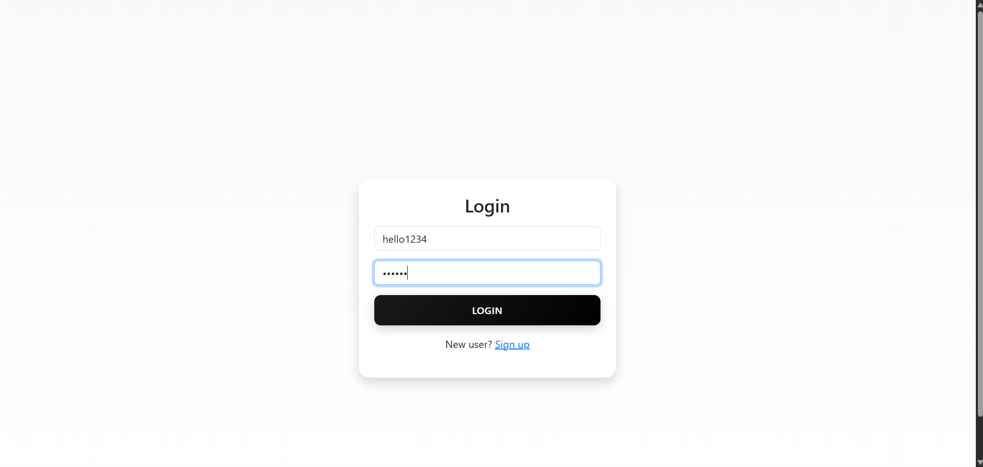
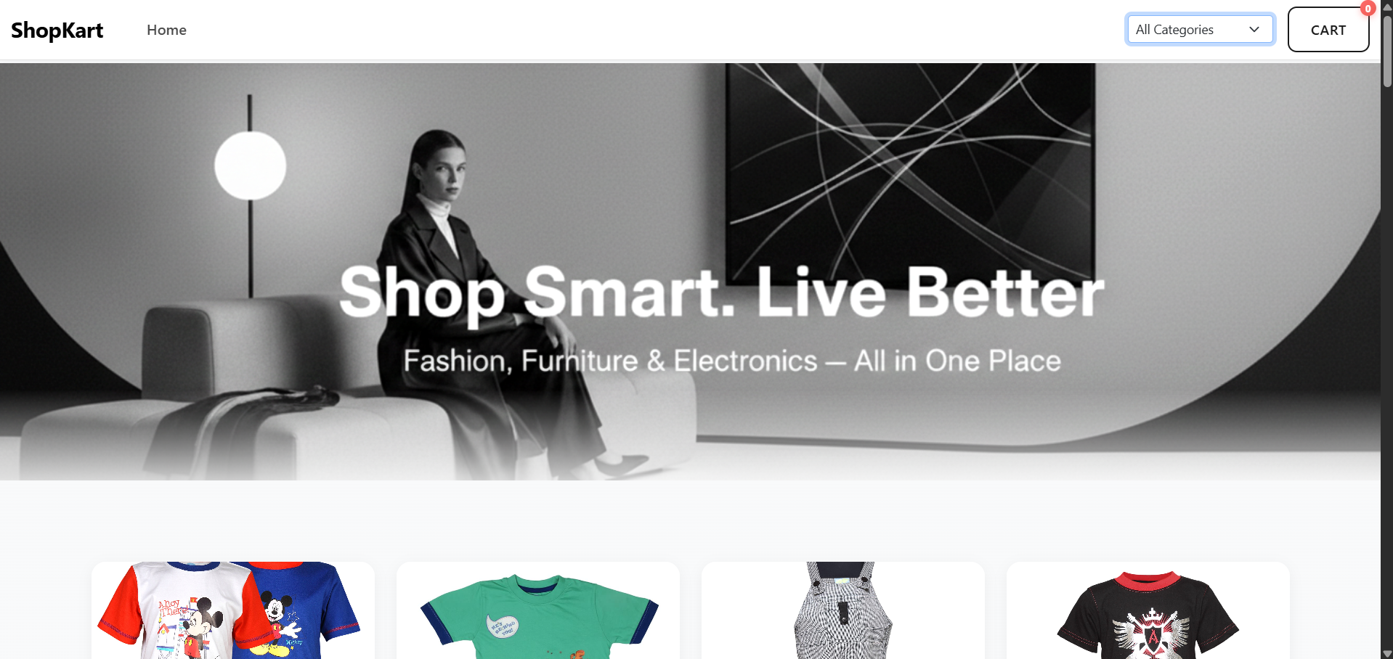
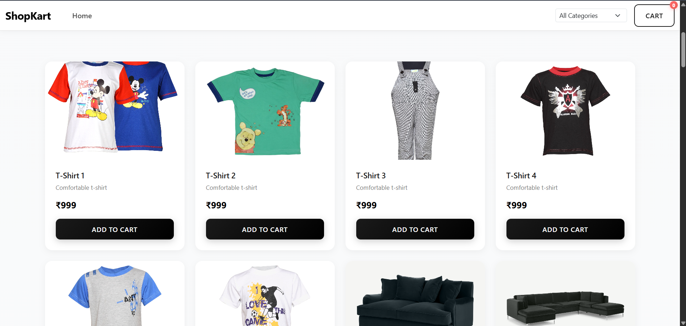
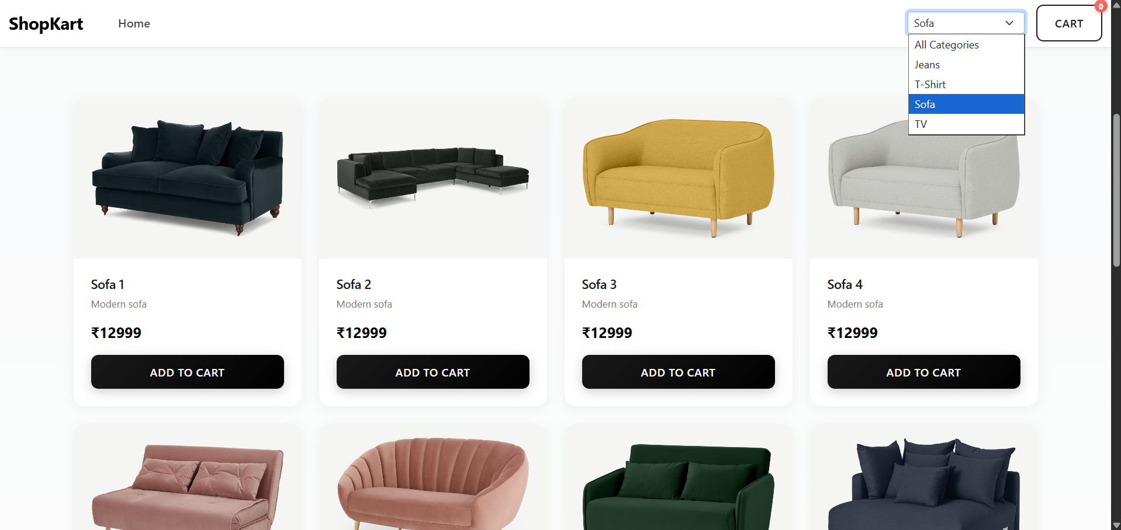
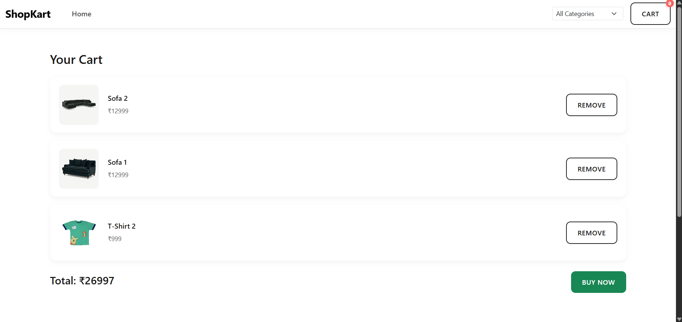
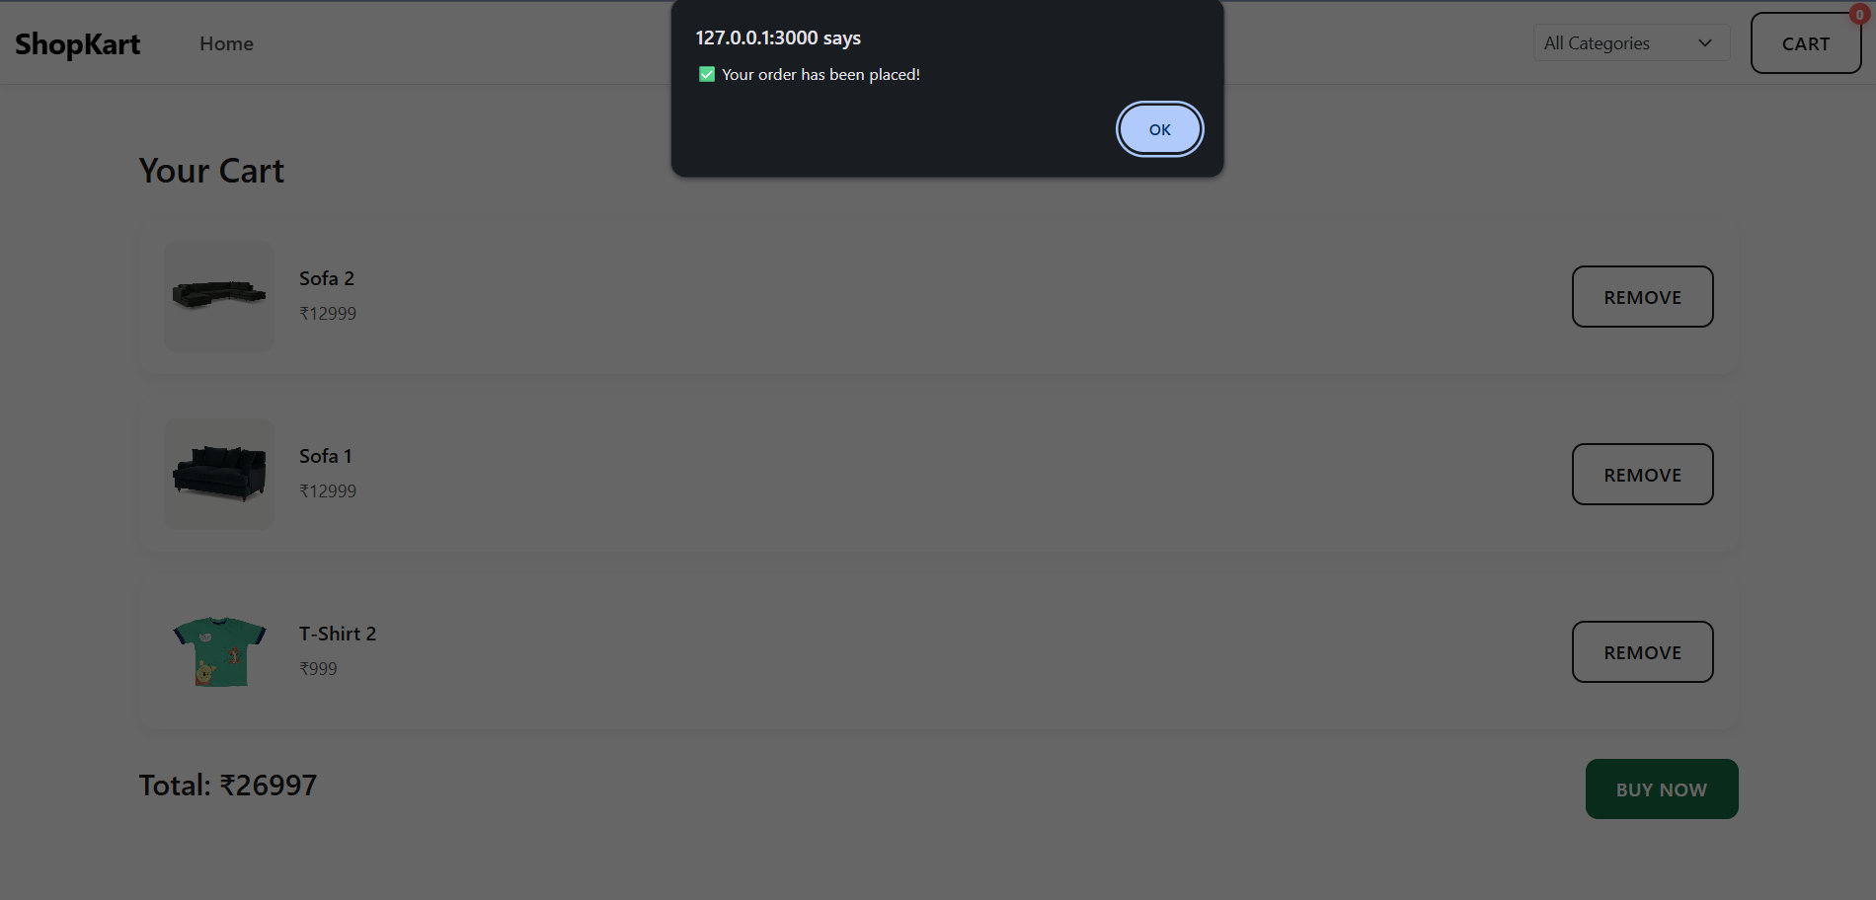

Conclusion :
In this assignment, we successfully designed and implemented a dynamic e-commerce web application using HTML, CSS, JavaScript, and Bootstrap CDN. The application demonstrates real-world features such as product filtering, cart management, user authentication, and responsive UI design. By using JavaScript and browser localStorage, the application provides interactive functionality without requiring a backend server. Integrating a real-world dataset enhanced the realism of the project. This assignment helped strengthen our understanding of front-end development, DOM manipulation, and dynamic web application design.

